Kathmandu University
Department of Computer Science and Engineering
Dhulikhel, Kavre


A Project Proposal
On
“KUConnect”

[Code No: COMP 206]
(For partial fulfillment of II Year/I Semester in Computer Engineering)

Submitted by
Shriharsh Sharma Acharya (1)
Rochak Adhikari (3)
Suyog Basnet (5)
Aditya Pokharel (32)
Nerish Shrestha (51)

Submitted to
Mr. Suman Shrestha
Department of Computer Science and Engineering

Submission Date: 8th November, 2024

Abstract
The growth of internet users in this digital world has made it necessary for universities to adapt with social media platforms for better and effective communication. KUConnect is a university-based social media web application which is to be developed with the ambition of prioritizing academic updates and interaction among the faculties and students through notices, public posts and discussions. The goal of KUConnect is to create a university focused online community with effective exclusion of external contents. The combination of React and Tailwind CSS will be utilized to create modern and responsive frontend of the web application whereas Express.js and MongoDB will be responsible for backend development which provides a powerful yet flexible environment. It is expected to provide a user-friendly web application that will increase the student connectivity, simplify event discovery and centralize university news. In conclusion, the web application attempts to bridge the gap in communication at university through technology.
Keywords: Social Media, Web Application, React, Tailwind CSS, Frontend, Express.js, MongoDB, Backend.

Table of Contents
Abstract i
List of Figures iii
Acronyms/Abbreviations iv
Chapter 1 Introduction 1
1.1 Background 1
1.2 Objectives 2
1.3 Motivation and Significance 2
1.4 Expected Outcomes 3
Chapter 2 Related Works/ Existing Works 4
2.1 Reddit 4
2.2 Slack 4
Chapter 3 Procedure and Methods 6
Chapter 4 System Requirement Specifications 8
4.1 Software Specifications 8
4.2 Hardware Specifications 8
Chapter 5 Project Planning and Scheduling 9
References 10

List of Figures
Figure 2.1.1: Reddit 4
Figure 2.2.1: Slack 5
Figure 3.1: Flowchart 7
Figure 5.1: Gantt chart 9

Acronyms/Abbreviations

GB
Gigabyte

GHz
Gigahertz

MB
KU
CSS
RAM
Megabyte
Kathmandu University
Cascading Style Sheets
Random Access Memory

- Introduction

Background
With the increasing power of digital technology in educational institutions, universities all over the world are now adopting social media-like platforms for better connections, active participation, and effective information distribution. Universities have now begun to adopt technologies such as Microsoft Teams, Slack, and Campuswire in order to let their students, faculty, and staff come together, provide personal updates, and keep the sense of community alive online. It is in this respect that modern universities are able to create online communities that interlink academic and social needs of the students, thus providing them with a sense of belonging-even virtually.
Despite such functionalities, existing solutions face certain drawbacks when tailored for educational settings. General-purpose social networking sites, such as Facebook and Instagram, are immensely interactive but usually do not meet the specific needs of communication which an academic institution demands. They tend to be distracting and often lack adequate privacy settings that meet academic interactions, hence filtering or prioritizing the content about university affairs is improbable. Moreover, non-university-exclusive platforms have led to information overload whereby important updates and academic notices get buried in irrelevant postings. For these reasons, traditional social media platforms cannot work effectively for most universities in engaging their students with university life.
KUConnect is proposed to address these issues by creating a university-based social media platform. It will prioritize academic updates and university-specific interactions, offering a focused environment for students and faculty to share notices, publish posts, and have topic-driven discussions where there is no external content present. By using the familiarity of social media features, KUConnect also prioritizes relevant academic interactions in an attempt to strike a good balance in offering an interaction platform free of distractions so that both educational and social needs are met in enhancing the general university experience of students.

Objectives
The major objectives of KUConnect are listed below:
- To create a centralized platform for KU news, announcements, and events.
- To provide real-time push notifications for important updates.
- To enable categorized news and threaded posts for easy navigation and relevance.
- To foster a more engaged and connected KU community through interactive features like commenting and sharing.

Motivation and Significance
The idea behind KUConnect was inspired by the fact that the majority of Kathmandu University (KU) students prefer Facebook groups to the official university website for news and events on campus. Despite being easily accessible, this reliance on social media frequently lacks structure and results in a disjointed experience. We want to close this gap by creating a KU-specific news platform with an easy-to-use interface that consolidates content in a more dependable and organized manner. With its classified news feeds, interactive features, and real-time updates, KUConnect will make it simpler for teachers and students to find pertinent information quickly. KUConnect will lessen reliance on outside social media by offering a simplified and easily navigable site designed just for KU, all the while encouraging a more involved and knowledgeable campus community.

Expected Outcomes
The expected outcomes of KUConnect are listed below:
- Centralized access to all announcements and news on campus.
- Real-time push notifications for critical updates.
- User-friendly and responsive interface.
- Personalized news feeds based on user preferences.

- Related Works/ Existing Works
Some existing platforms related to our project are mentioned below:

Reddit
Reddit is an online platform that hosts communities, or "subreddits", focused on specific topics where users can post content and participate in threaded discussions. With its upvoting and downvoting system, Reddit emphasizes community-driven discussions, allowing users to interact meaningfully on various topics. This structure supports long-form, topic-based discussions, which can serve as a model for creating academic and interest-focused forums within a university social media app.
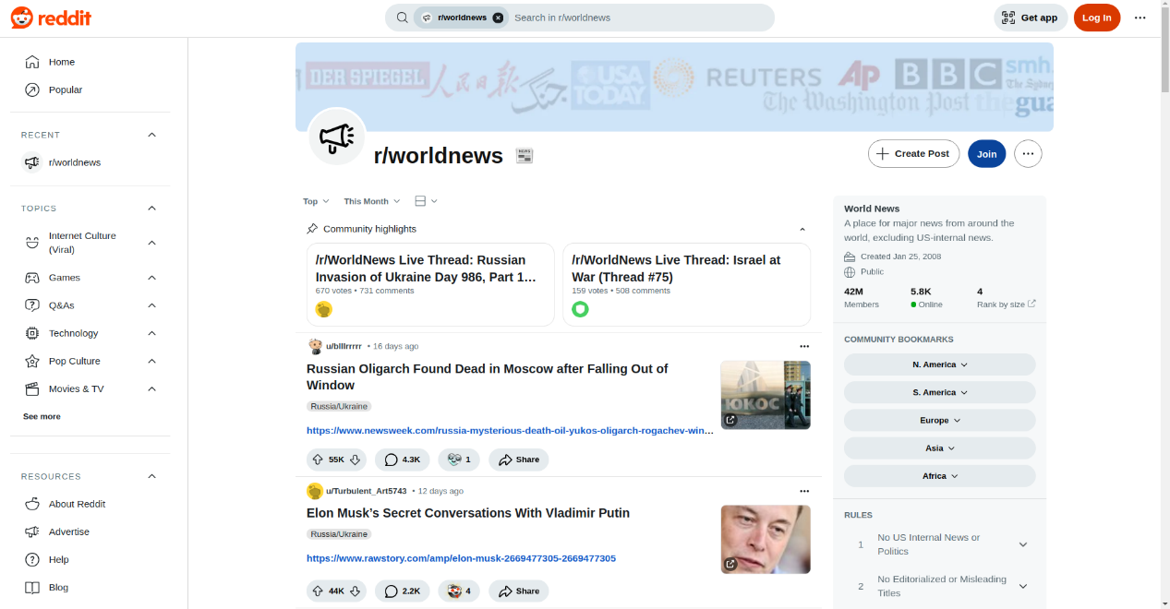
Figure 2.1.1: Reddit

Slack
Slack is a widely used communication and collaboration platform that allows teams to stay connected in real time. It organizes conversations into channels, which can be dedicated to specific projects, topics, or teams, helping users keep discussions focused and organized. Channels can be public for the whole team or private for specific members. Slack also supports direct messaging for private one-on-one or small group chats, making it easy to have quick, focused conversations. Additionally, customizable notifications help users stay updated on important conversations, while the option for voice and video calls makes remote collaboration even more effective.
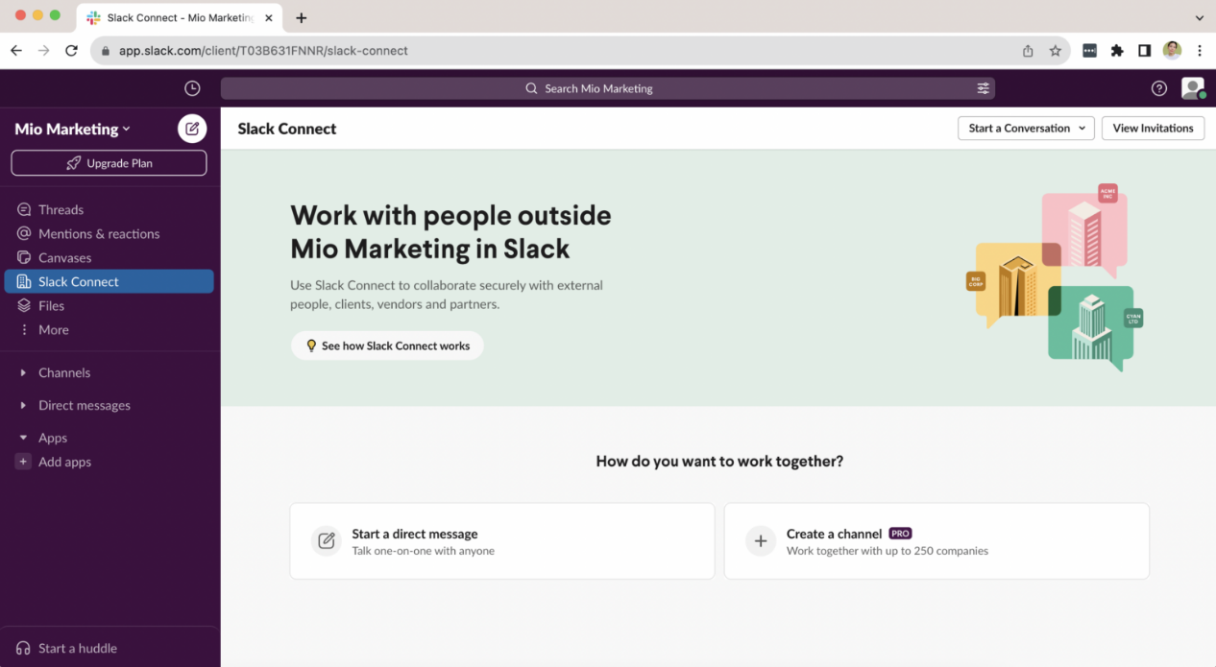
Figure 2.2.1: Slack

- Procedure and Methods
The procedure that will be followed in the course of development of KUConnect is systematically presented below:
- Research and Study: This phase involves examining existing platforms, identifying key areas for improvement, exploring the technologies that will be used in development and work distribution.
- Front-end Design: This phase centers on development of a responsive, user-friendly interface using ReactJS to support seamless interactions across the platform. It includes implementing React Router for smooth navigation, utilizing Tailwind CSS for a modern and adaptive design.
- Core Programming: This phase covers the functionality of KUConnect, including authentication, data management, and real-time communication. It will implement a server-side logic using Node.js with Express.js and use MongoDB as the database for efficient handling of user information and posts. WebSockets integration will enable real-time chat and live updates, enhancing user engagement.
- Testing and Debugging: This phase involves thorough testing to ensure sound performance. Unit tests will be conducted using Jest. Further debugging and patching security vulnerabilities will take place to ensure a seamless and secure experience for the end-user.
- Documentation: This final phase of project development involves processes such as creating presentations and reports of the project.
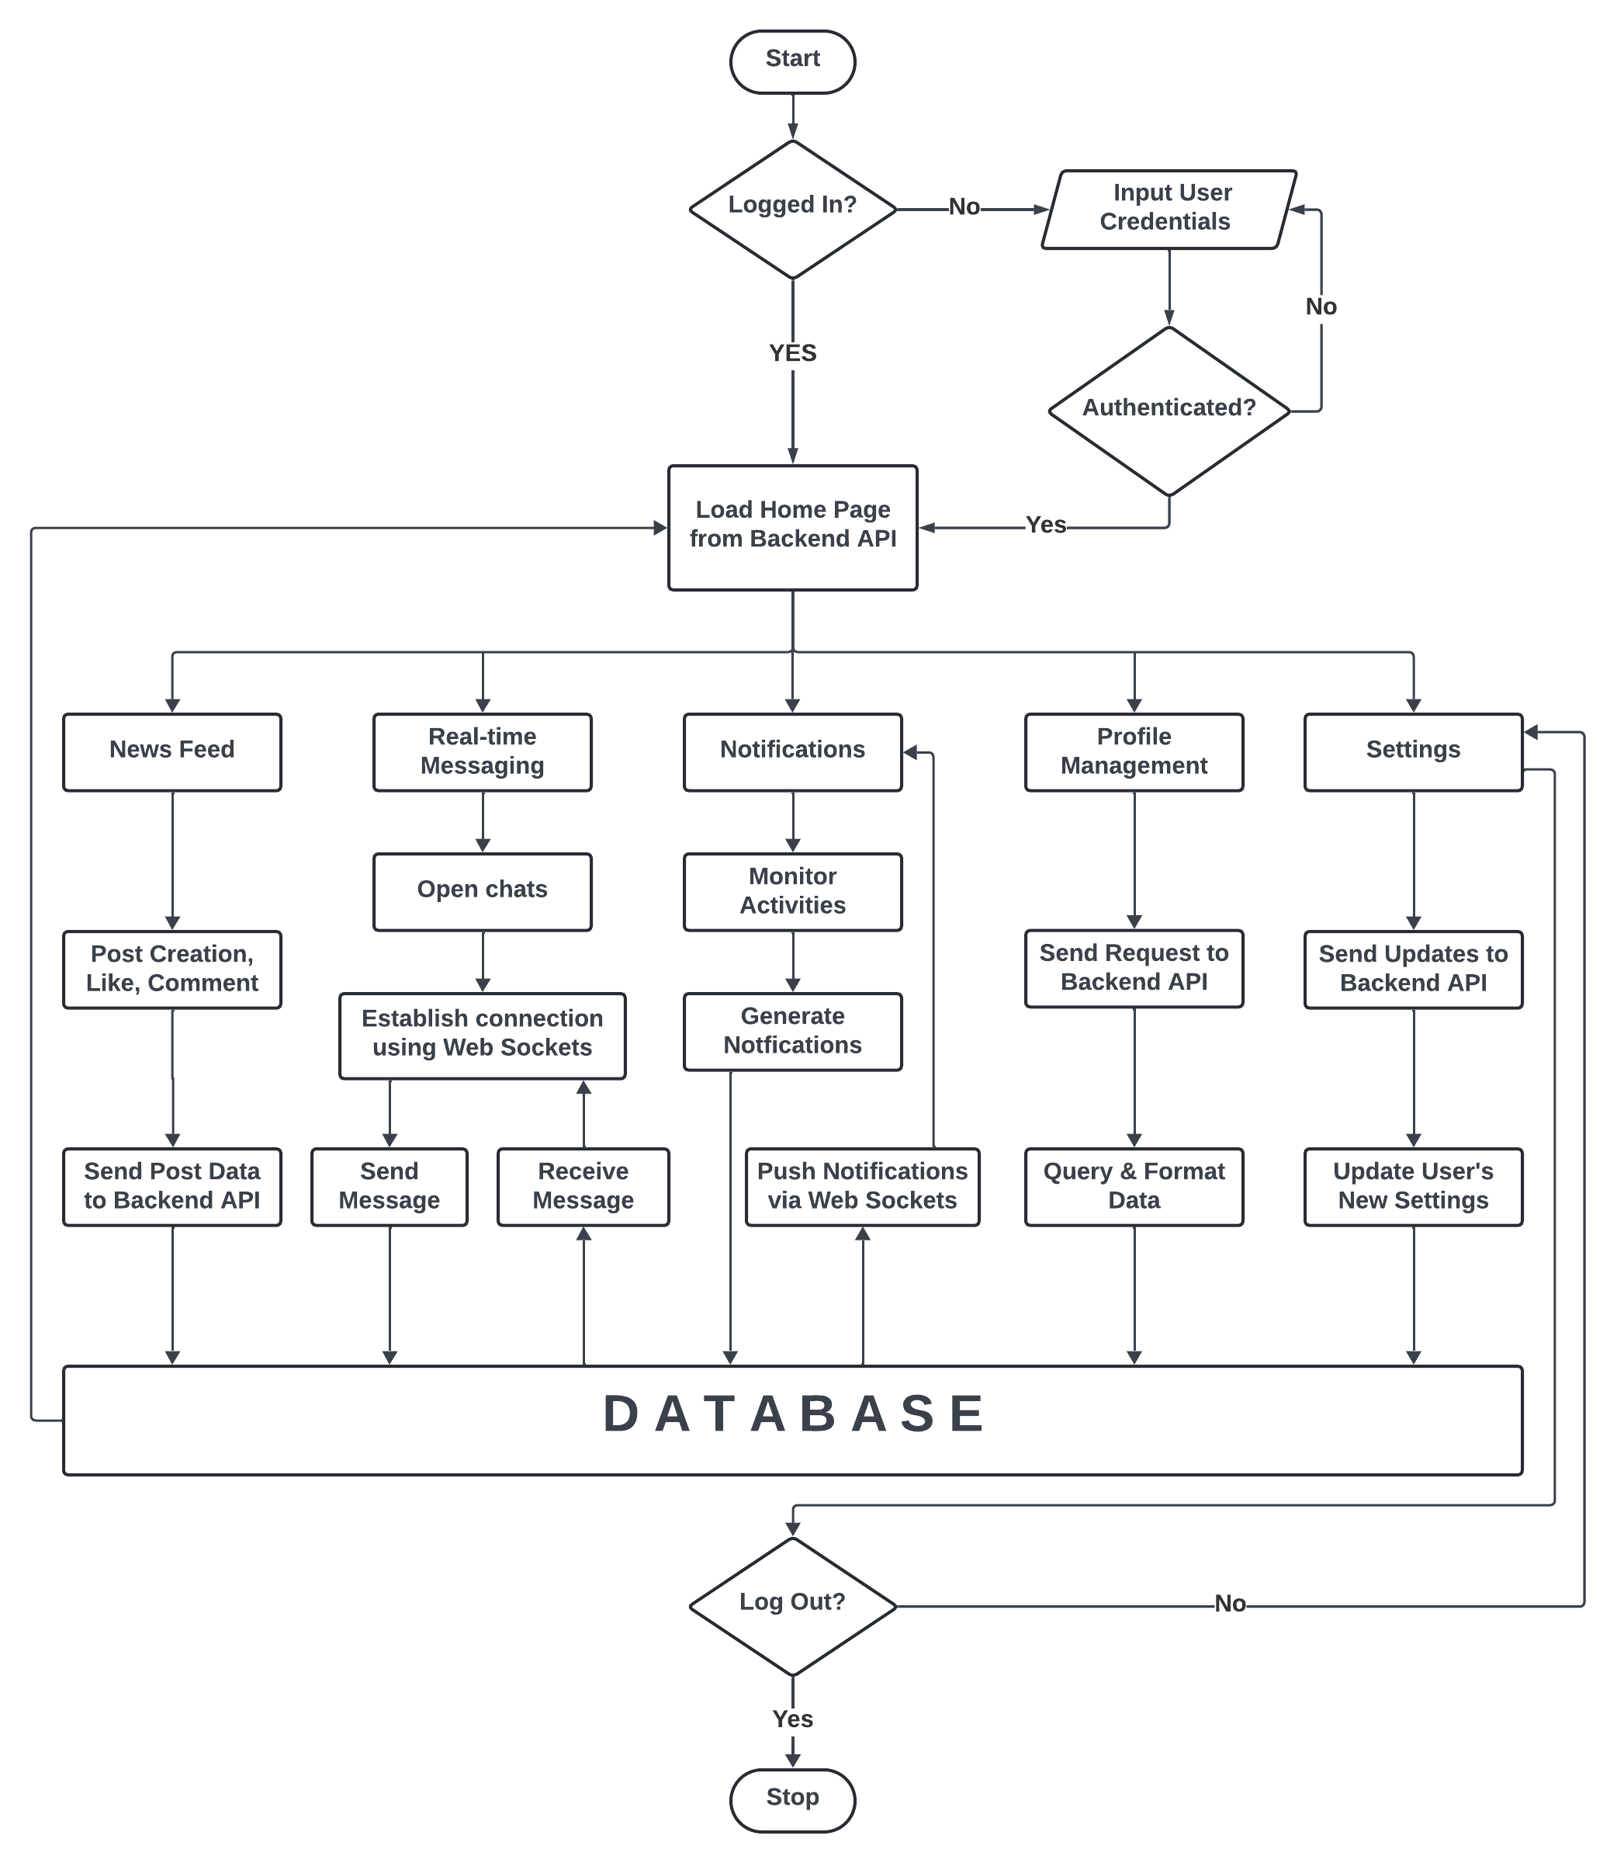
Figure 3.1: Flowchart
- System Requirement Specifications

Software Specifications
Since this social media application for Kathmandu University will be developed as a web application using JavaScript, the system requirements are aligned with modern web applications built using JavaScript frameworks. The application will utilize Mongoose for database management, React Native for the user interface, and web sockets for real-time messaging. The following are the suggested software requirements for KUConnect:
- Browser Compatibility: The application will support modern browsers, including Google Chrome (version 70 or later), Firefox (version 65 or later), Safari (version 13 or later), and Microsoft Edge (version 79 or later).
- Operating System Compatibility: The web application will work across platforms, including Windows, macOS and Linux as long as they support the compatible browsers.
- Internet Connection: A stable internet connection is required, especially for real-time messaging through web sockets.

Hardware Specifications
To ensure optimal performance, the following hardware specifications are recommended. However, the application is designed to be lightweight and can function on most modern devices. The suggested hardware requirements are:
- Processor: 1.5 GHz dual-core processor or equivalent.
- Memory: 4 GB of RAM.
- Storage: 200 MB for cache and local storage.

- Project Planning and Scheduling
The dedication and contribution of each member is required for the completion of this project. Teamwork plays a significant role to achieve this goal. In order to develop the web application in the given time, which is limited, we decided to break it down. It will help us to accomplish the tasks of this project work smoothly and calmly without having to rush at the end, avoiding last-minute stress. The rough estimation of the time allocation for different tasks is illustrated below in the Gantt chart.
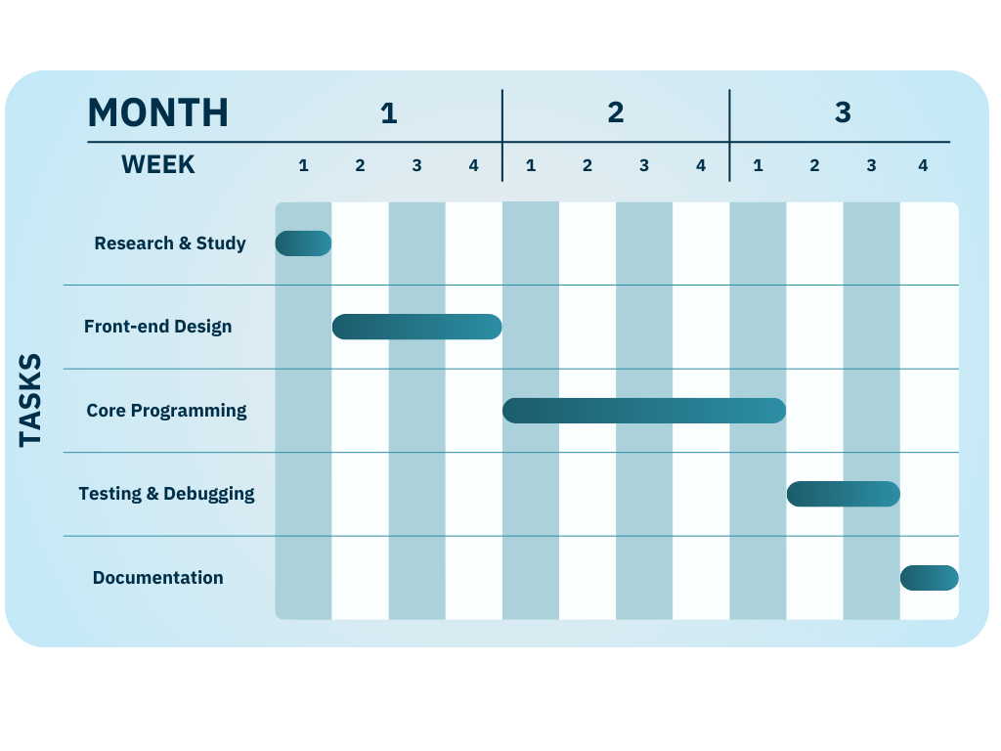
Figure 5.1: Gantt chart

References
Reddit. (n.d.). Reddit – Dive into anything. Retrieved October 31, 2024, from https://www.reddit.com
Slack. (n.d.). Slack overview. Retrieved October 31, 2024, from https://www.slack.com

